1. **PURPOSE:**

To provide a procedure For Operation and calibration of Agilent 7890B GC.

1. **SCOPE:**

This procedure is applicable to the GC following in Quality Control laboratory.

Make : Agilent Technologies

Model : Agilent 7890B

Instrument ID No. : DIPL/QC/INS/GC/002.

1. **RESPONSIBILITY:**
   1. Analyst-QC shall be responsible to follow this SOP.
   2. Head-QC/Designee shall be responsible for ensuring implementation of this SOP.
   3. Head-QA/Designee shall be responsible for monitoring overall compliance of this SOP.
2. **DEFINITIONS:**

Nil

1. **PROCEDURE:**
   1. **Operation:**
      1. Check that the instrument is clean and free from dust, if not clean with a soft cloth duster
   2. **Basic Operation**
      1. Ensure that the system is connected to stabilized power supply.
      2. Put on the main switch of the instrument. Identify the column to be used for analysis enter the column details in to the edit column.
      3. Connect the prescribed column in the right direction; connect the tubing from the injector to one end of the column and other end to the tugging towards the detector.
   3. **Creating initial admin user:**
      1. 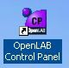 Double click on the **Openlab control panel**.
      2. Click Administration in the navigation pane and select System Configuration.

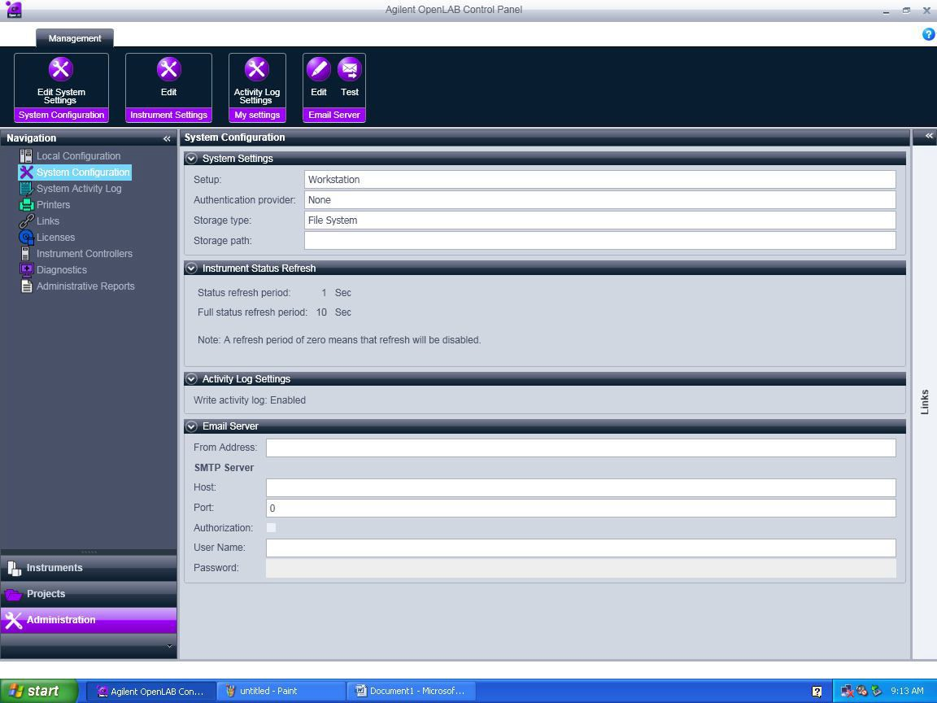

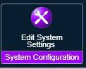Click on Edit system settings

* + 1. The below screen will appear. In the first scroll bar select internal and click Next

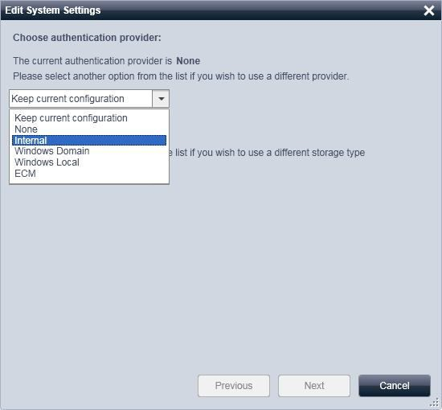

* + 1. The below screen appear. Click on Create Account.

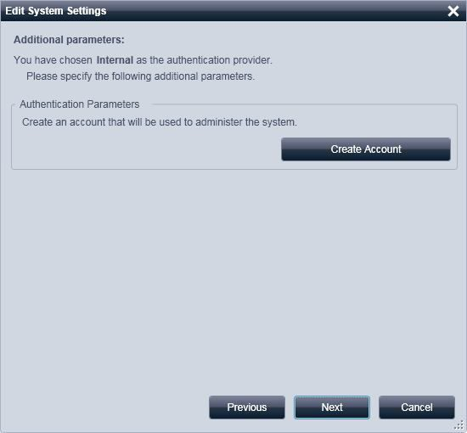

* + 1. Create Administrator Account window will appear. Enter User Name, Full Name, Password and confirm Password details and click OK. ( ** Note: Initial Admin user is must to enable security policy’s and user creation options in the control panel)

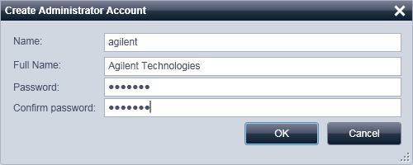

* + 1. Below screen will appear. Click Next

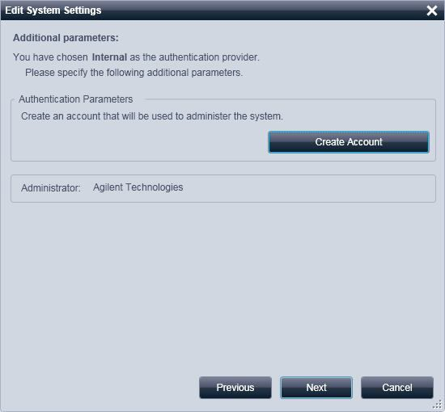

* + 1. Below screen will appear. Click on apply and OK in the next screen, it will close and restart the control panel with user credential options.

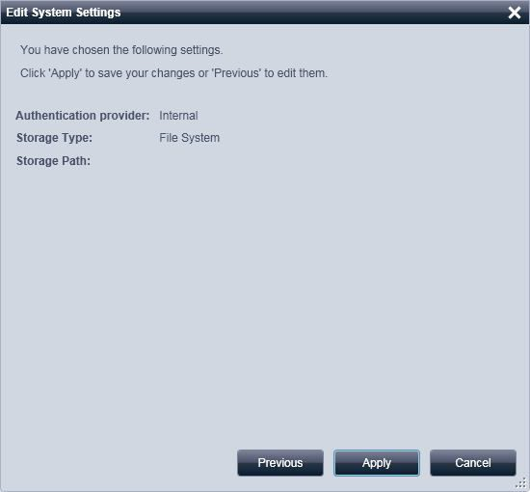

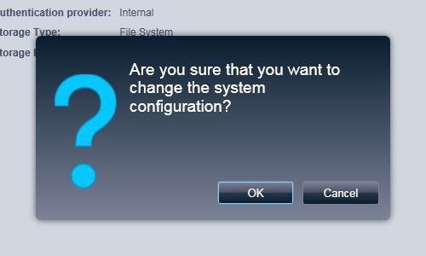

* + 1. Enter the created Admin user and password and click OK.

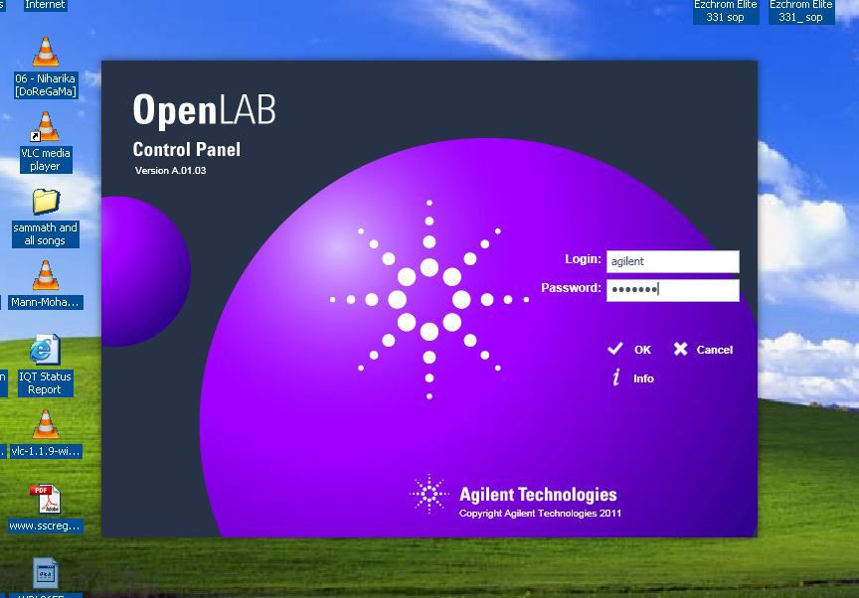

* + 1. Control Panel window will open with enabled Security policy and users Options

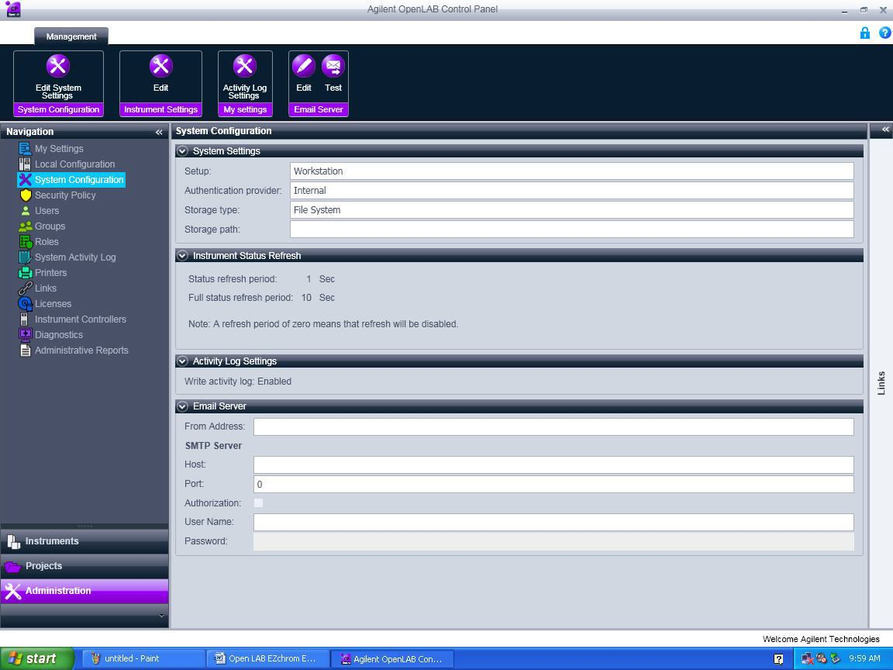

* + 1. Click Administration -> Security Policy -> Click Edit 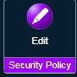 and edit Minimum password length and Password expiration period (days) if required.
    2. To create users click Administration and click on users -> click create  and follow the screen.

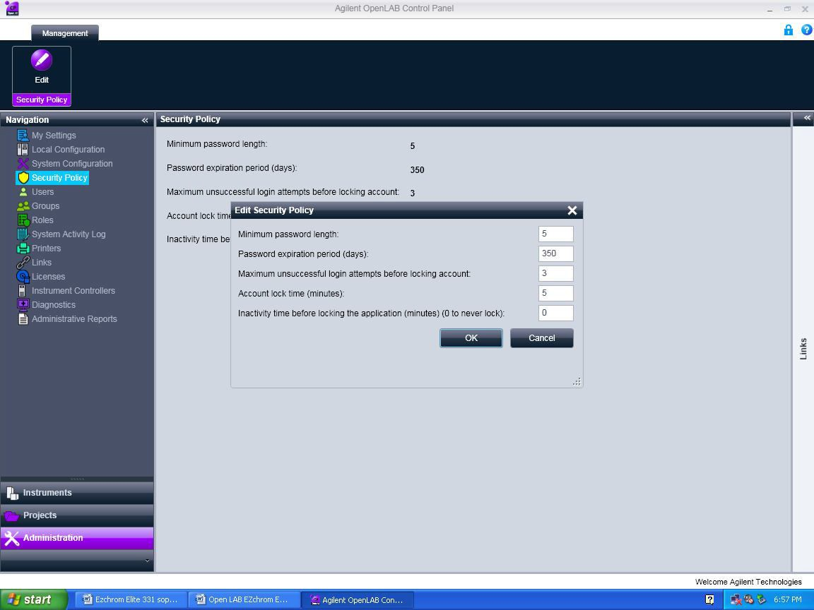

* 1. **Creating data storage path**
     1. Create a Data folder (EX: “Projects” folder or “EZDATA” folder) in C drive or D drive.
     2. In Administration pane click on System Configuration -> Edit System setting and in the second scroll window select File System and click Next.

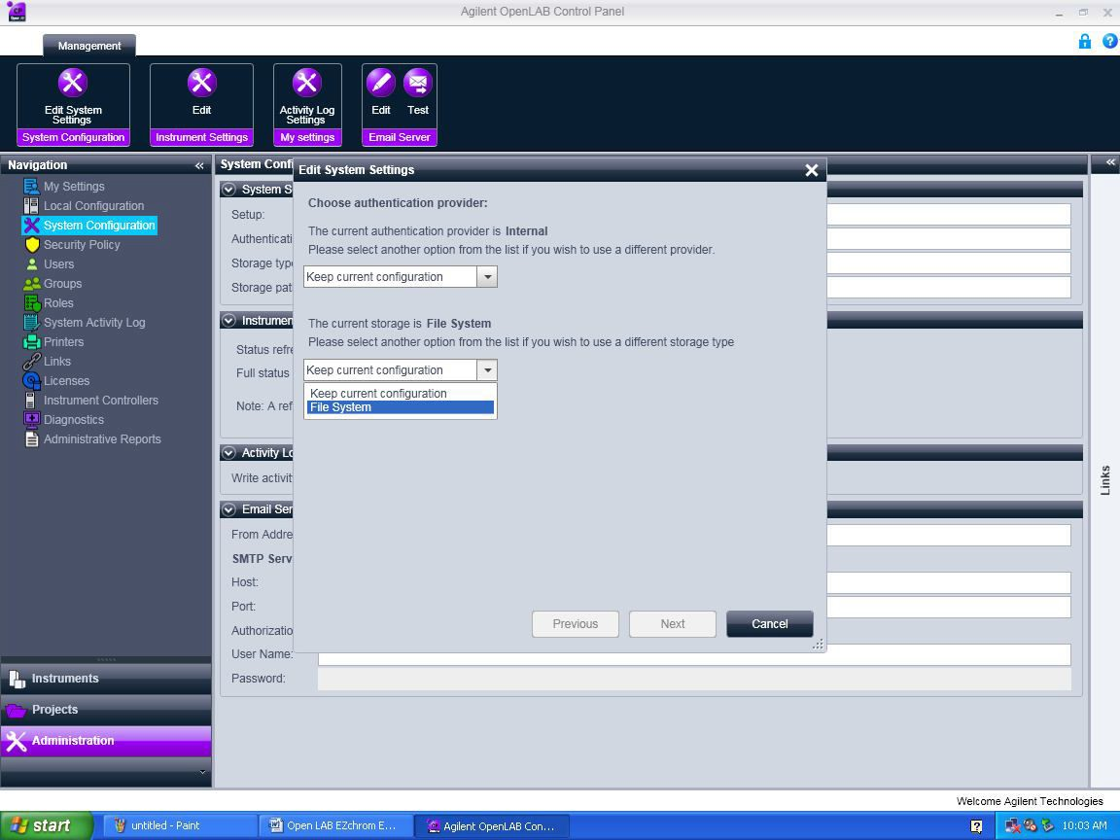

* + 1. The below screen will appear. Browse the data folder (Ex: projects folder) which is already created in the C drive or D drive. Select the created folder and click OK.

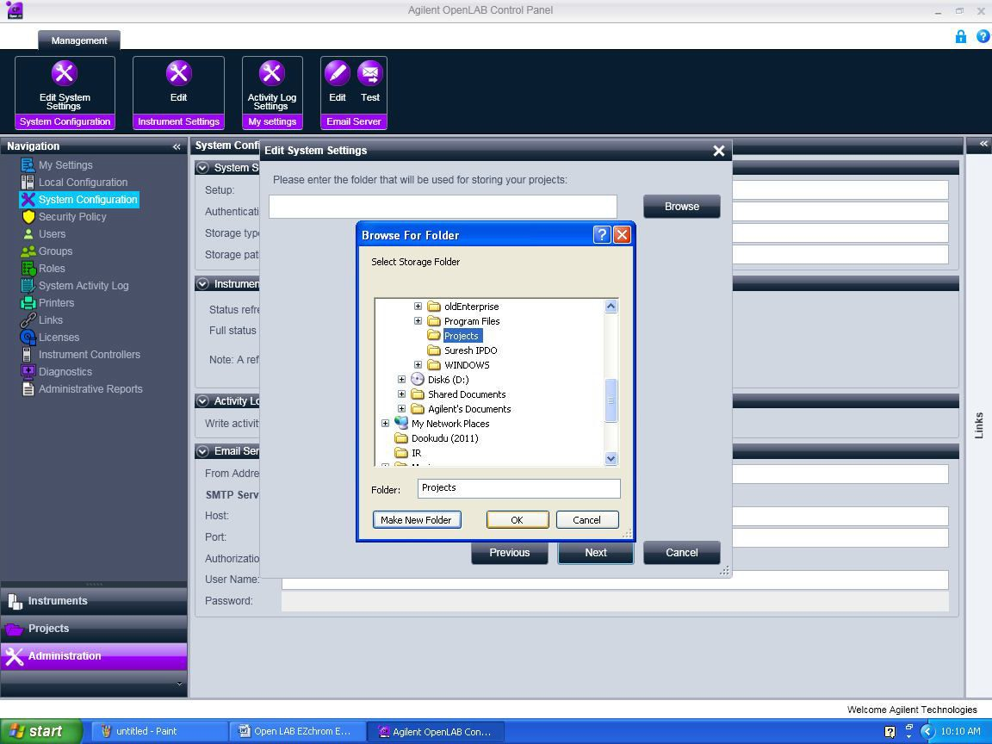

* + 1. Below screen will appear. Click on Next and Apply in the next screen and click OK in the following window. It will close and restart the control panel.

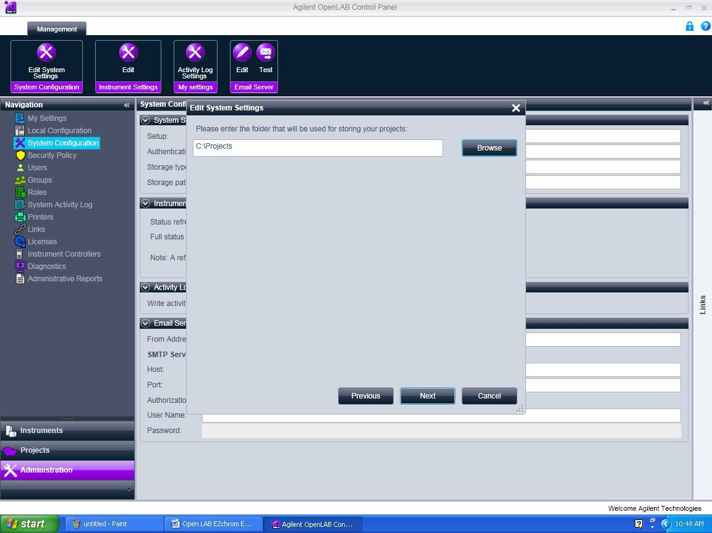



* 1. **How to Crate Project:**
     1. Click on Projects in the navigation pane and click on Create  -> click on Create Project.

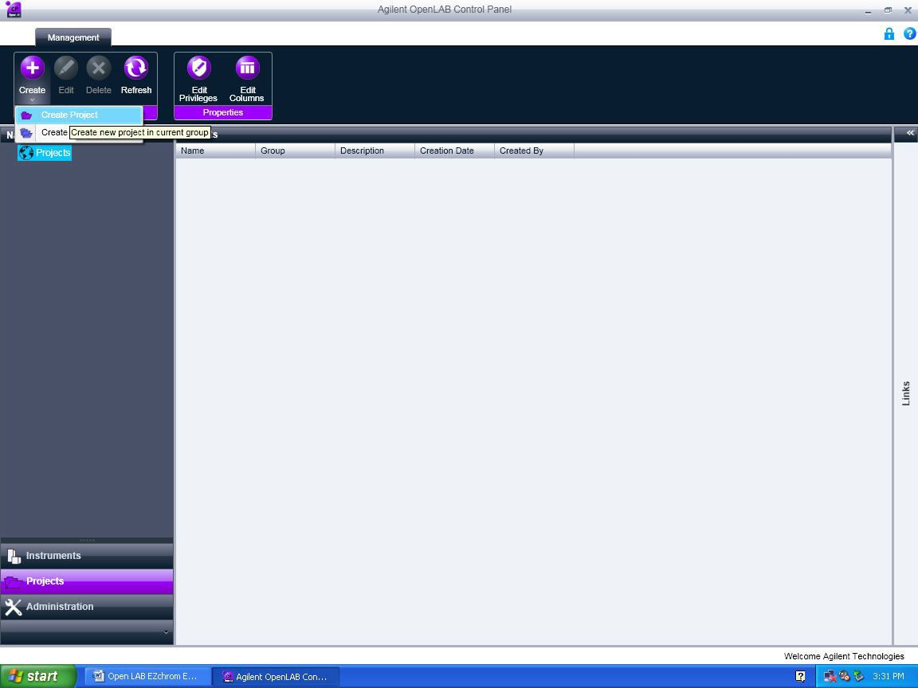

* + 1. In the below screen enter Project Name (Ex. Demo) and project Description -> Click on EZChrom.

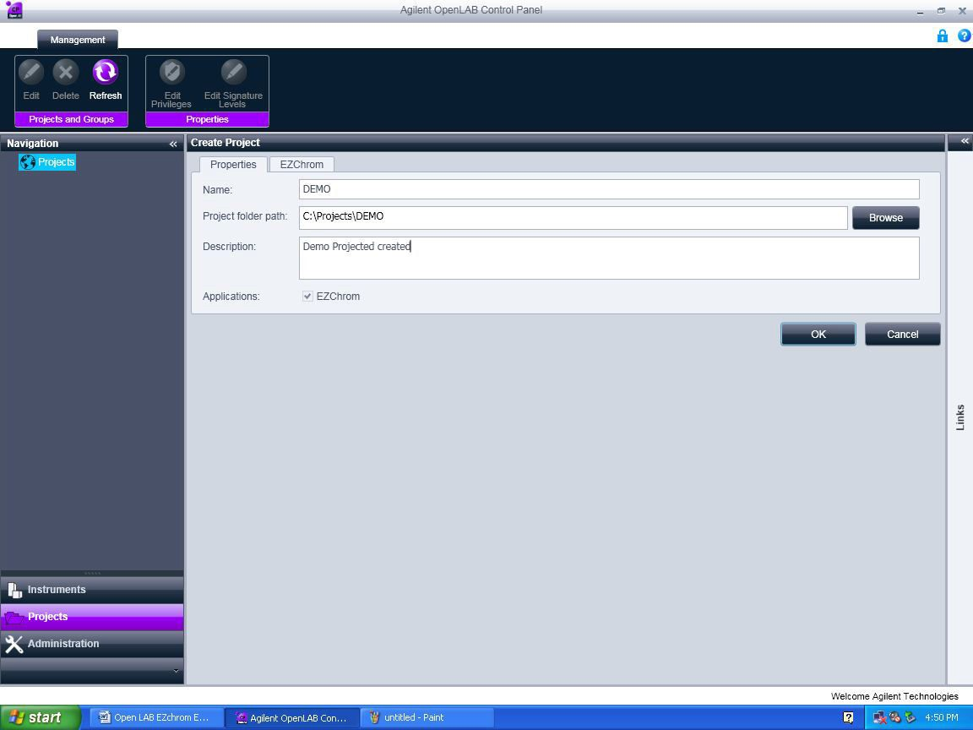

* + 1. The below screen will appear. In Project Options Select the checkboxes for Save all analysis result in data file.
    2. In Result Set Mode select Result Package Mode and select the below two options as shown in the screen shot.
  + Include Method and Sample Prep files in Result Package.
  + Include Report Template files in Result Package.

**\*\* *Don’t Select the Update Original Methods during acquisition with analysis updates***

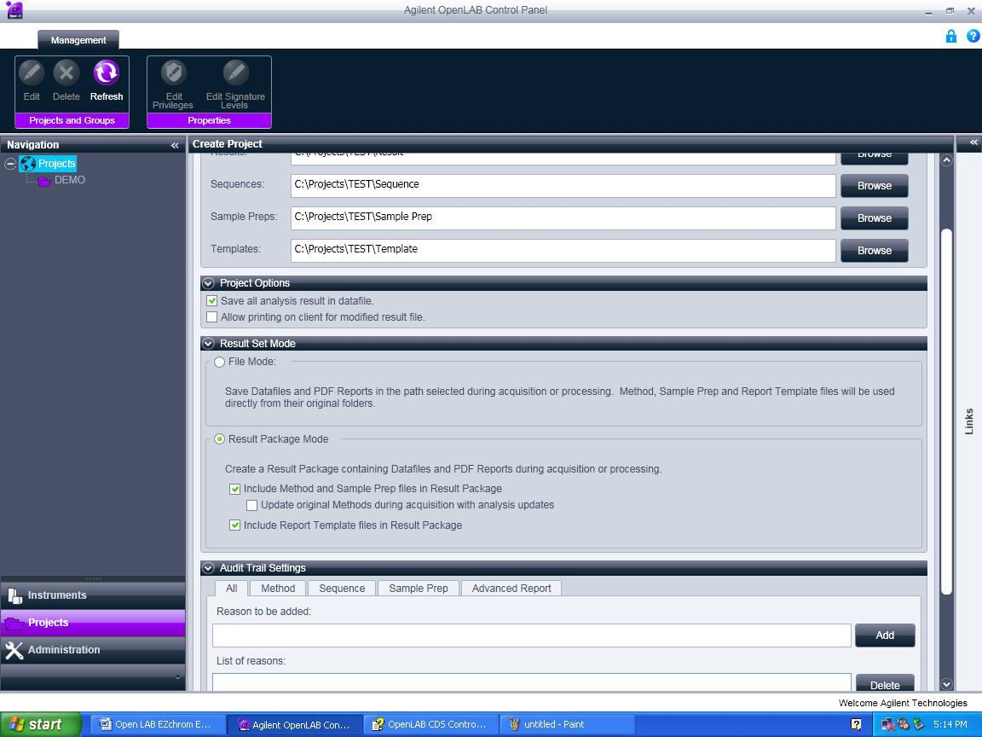

* + 1. If required you can enable Audit Trials in the Audit Trial Setting window. When finished click Ok.

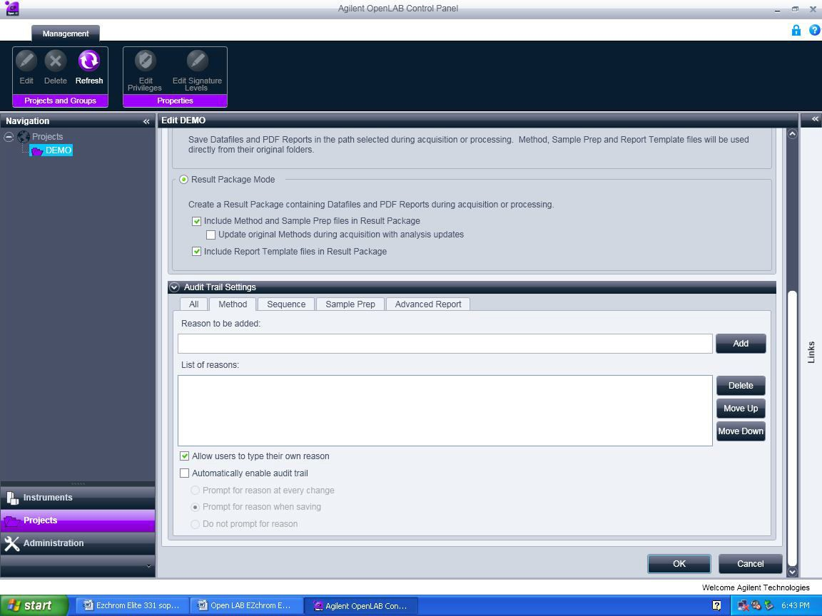

* 1. **Create Method** 
     1. Double click on the Open LAB Control Panel icon. 
     2. Enter the Use ID and Password and click ok.

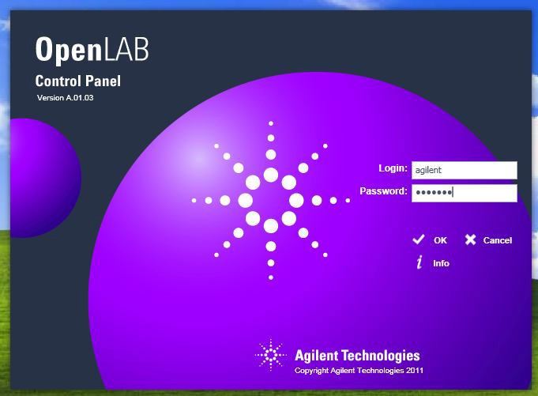

* + 1. Select the Instrument (GC) in the navigation (instruments) pane and browse to select the required project and click Launch for online and Launch offline for offline.

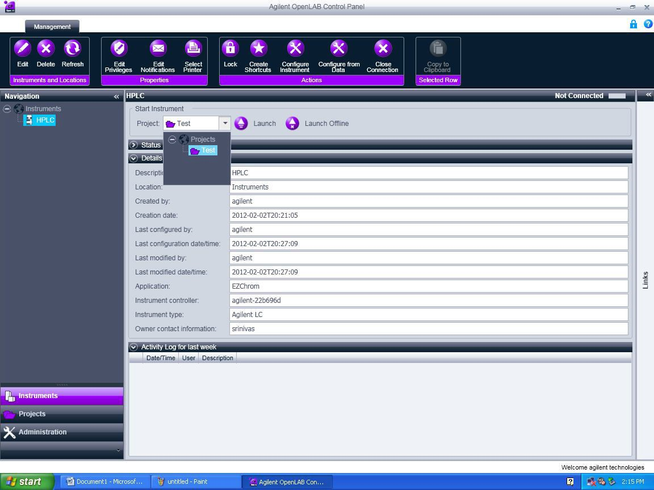

* + 1. Close the instrument wizard window.

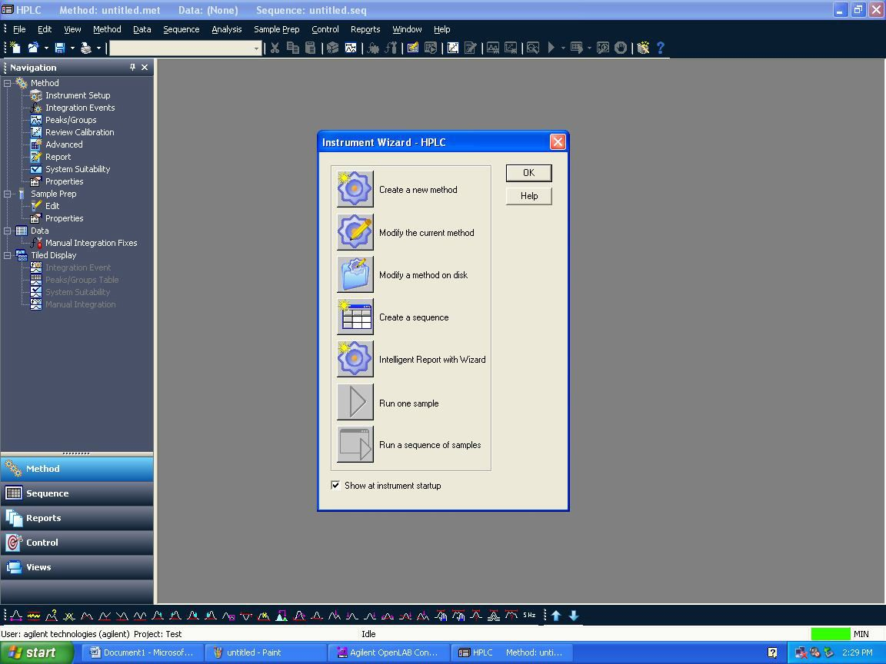

* + 1. Click file > New > and select Blank.met in New file Template and click ok. It will load the Instrument setup window

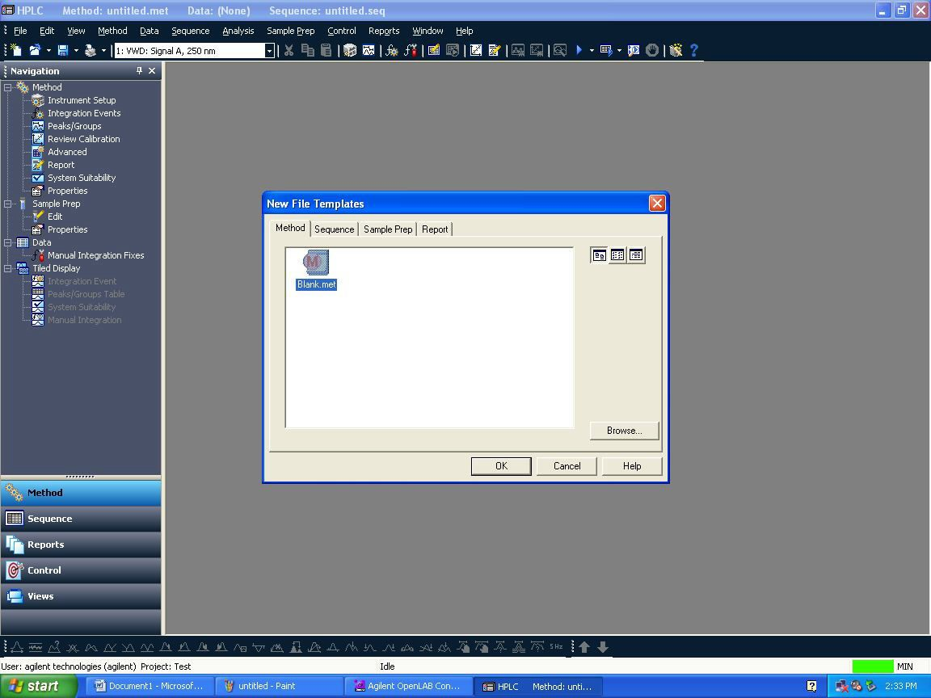

* + 1. Select inlet and enter the inject temperature.

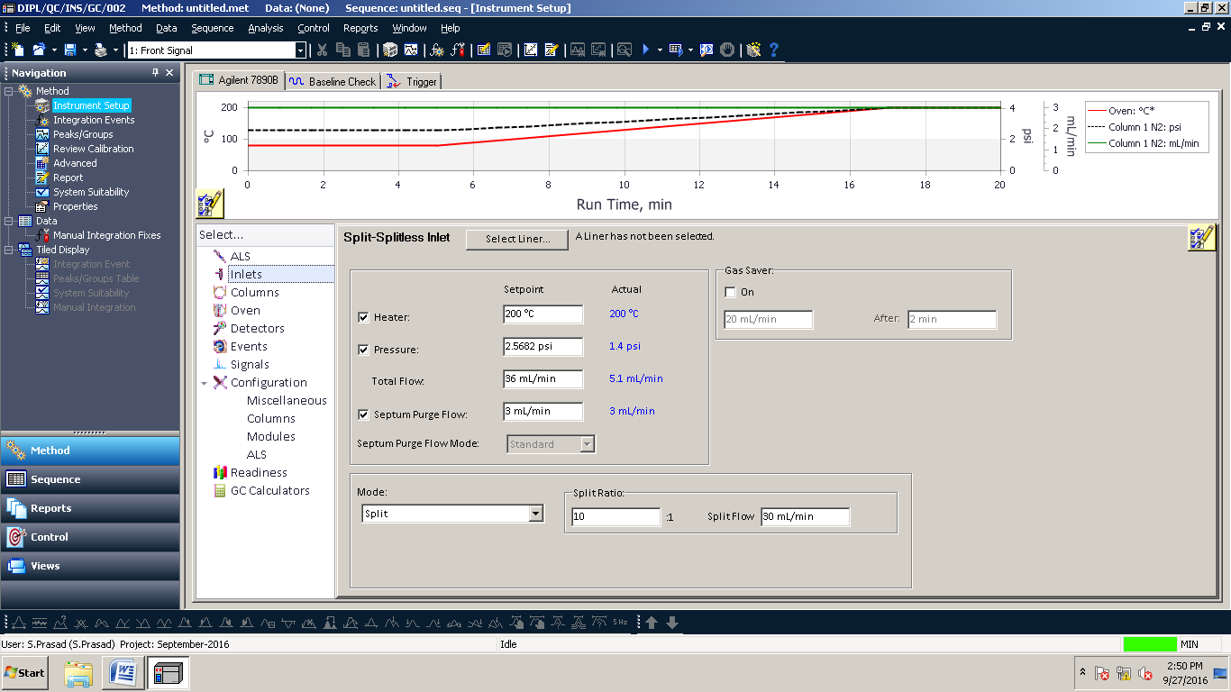

* + 1. Select the column the below screen will appear and install the column and enter the flow, pressure and average velocity

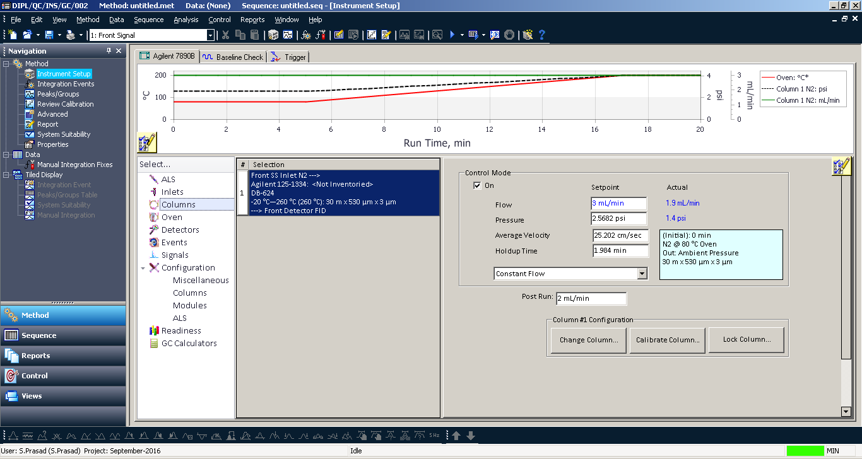

* + 1. Select the Oven the below screen will appear and enter the oven programme.

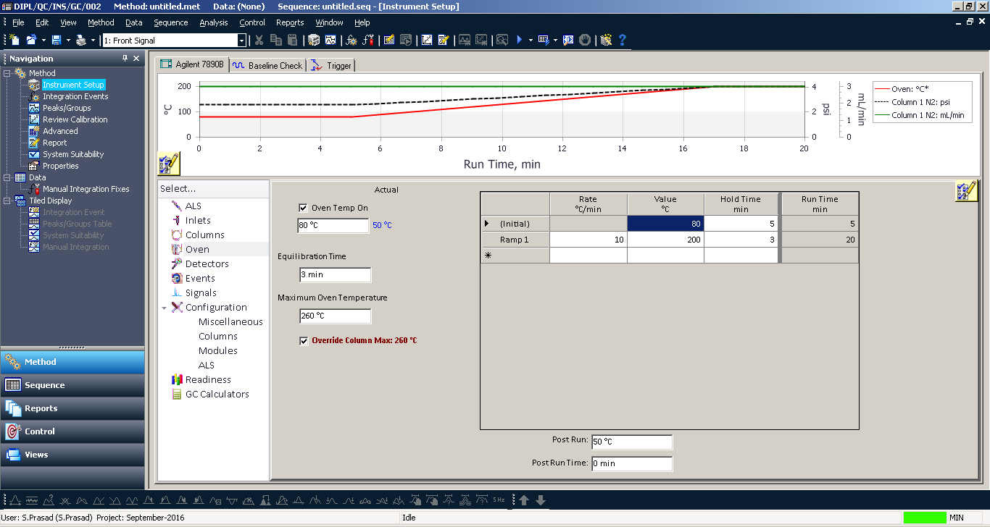

* + 1. Select the detector the below screen will appearand the enter the detector temperature

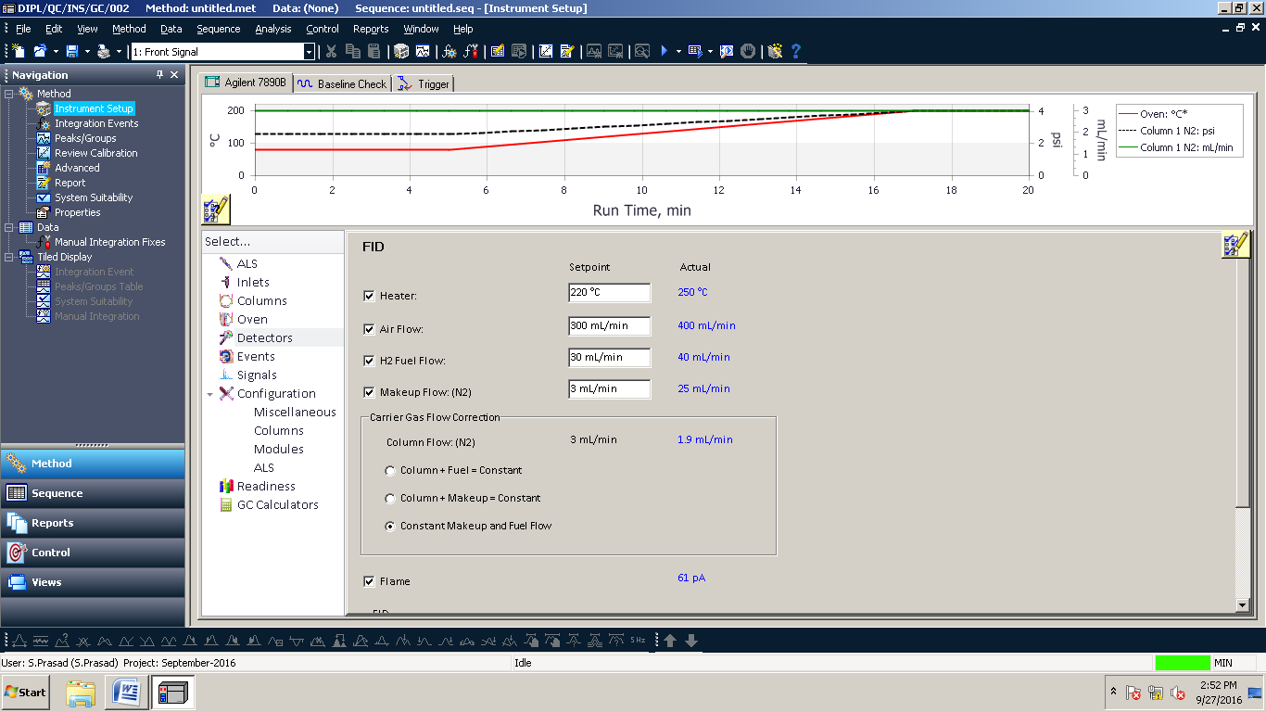

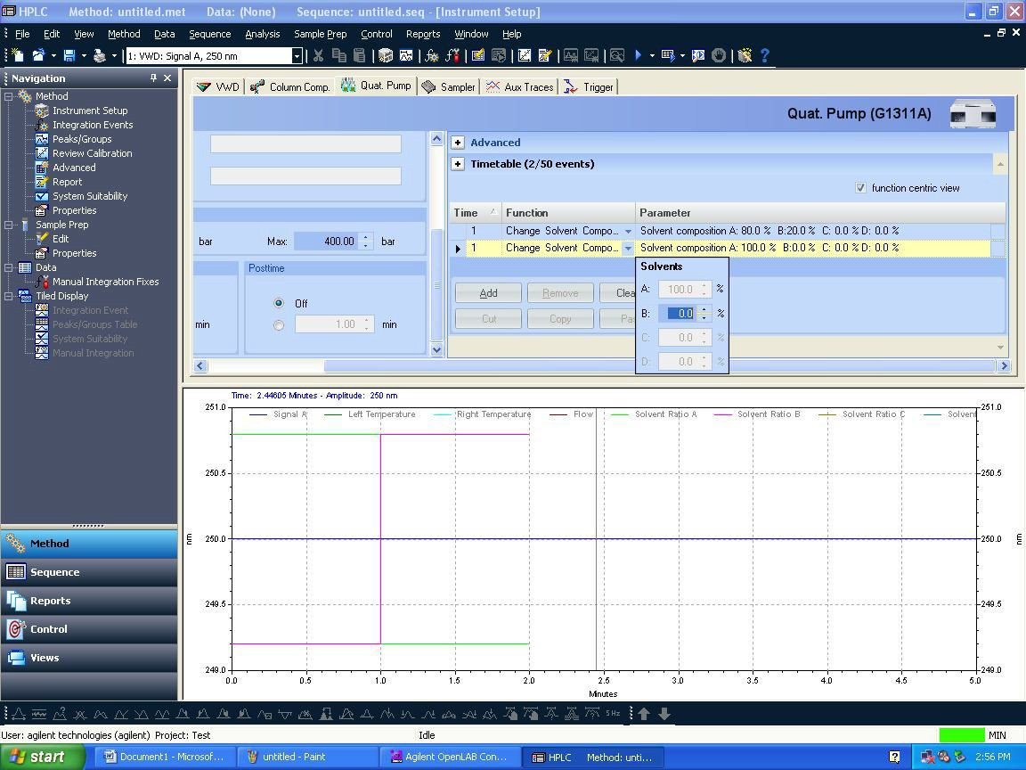

* + 1. After editing all the method parameters, you need to save the method by clicking File-> Save As-> Method.

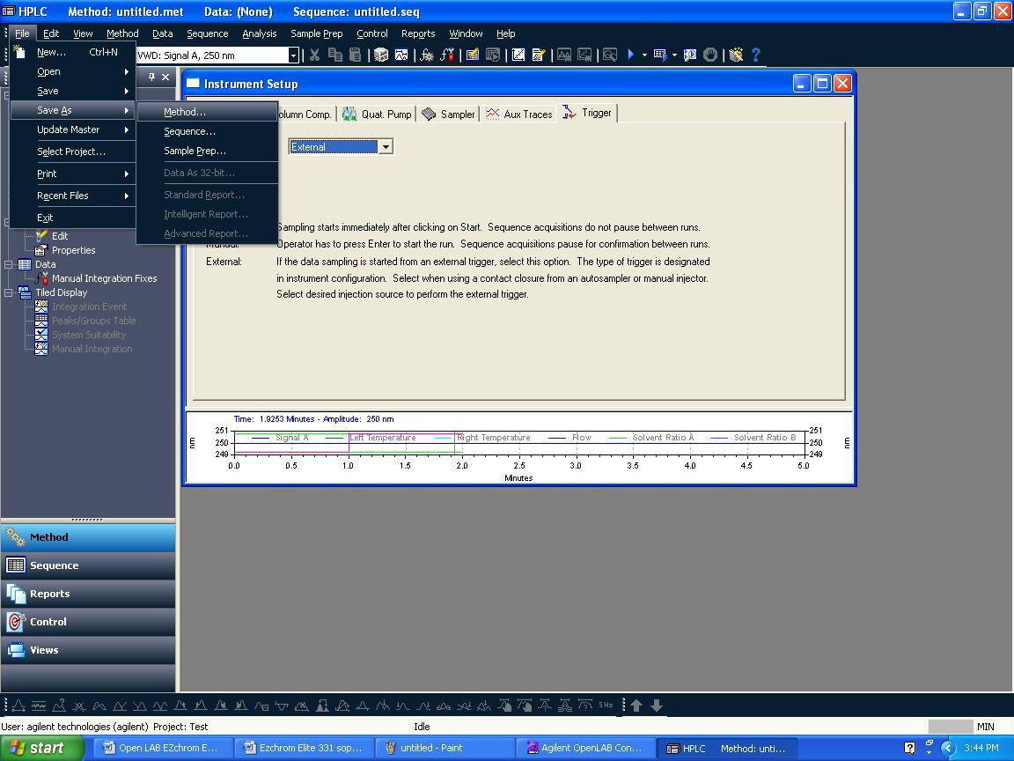

* + 1. Save method screen will appear. Give Method file name in blank space and click save.

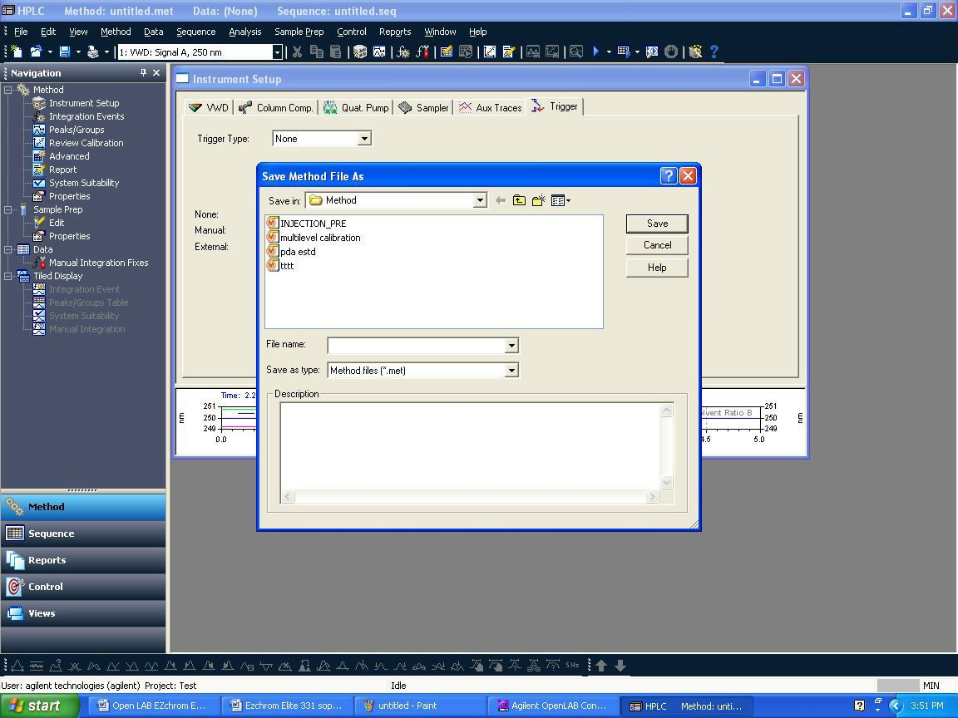

* + 1. After saving method file, down load it into instrument by clicking Control →Download method

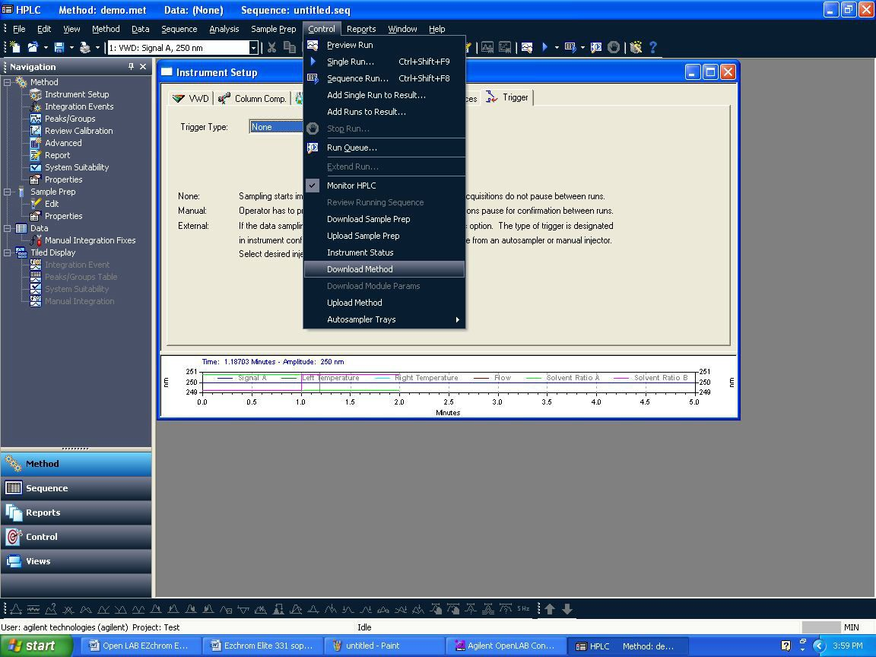

* + 1. After downloading the method, you can see online signal before injection i.e. to check baseline gets stabilize or not. Click On View →Online signal.

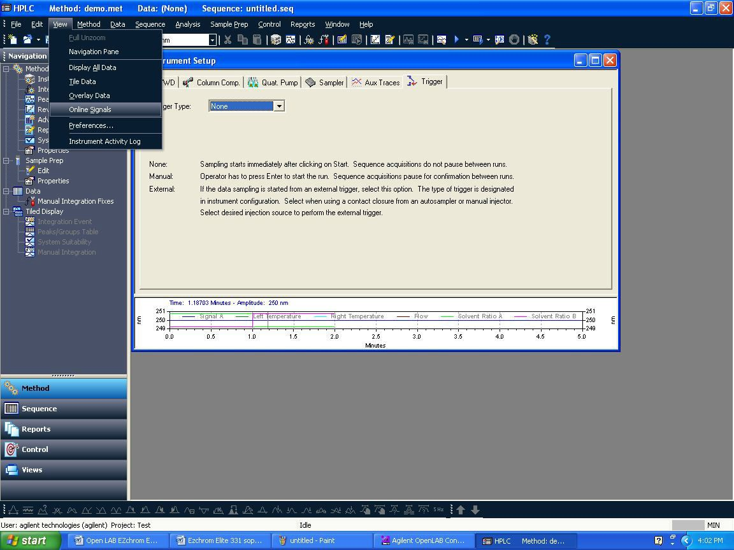

* 1. **How to do single run acquisition:**
     1. Click on Control→Single Run. One window will appear and in that need to enter sample ID, Data file name, Result set name, Vial number and injection volume.

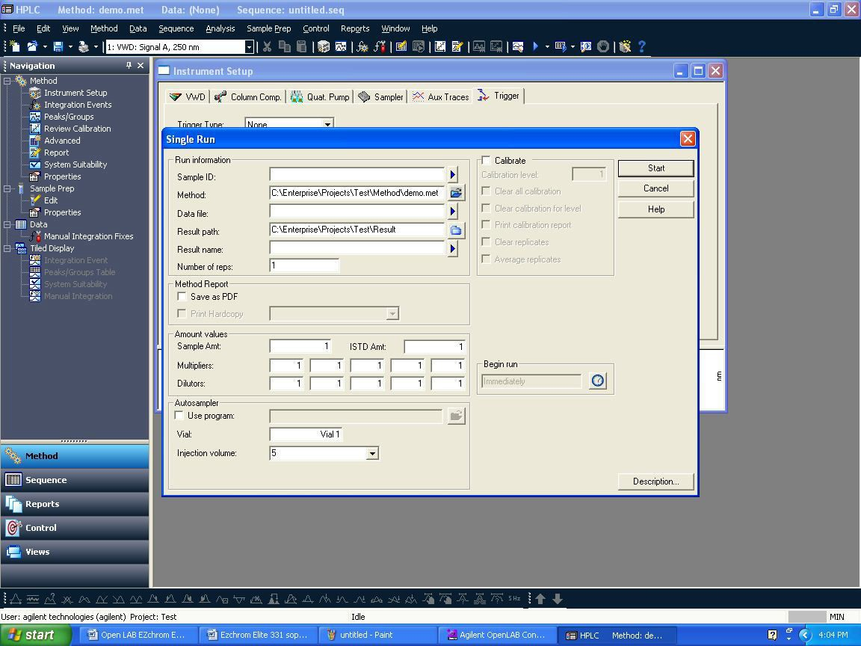

* + 1. Enter sample ID, Data path (browse your path if required), Data file name. In Sample ID and Data file name by clicking triangle symbol , you will be able to give different styles of naming sample ID and data file. Here let select **Increment number**. Give Number of unknown runs in sequence (i.e.: no. of lines you want to create in sequence, for exp. give: 10). Also you can give repetitions per run.
    2. After filling detail in below window, click on **Next.**

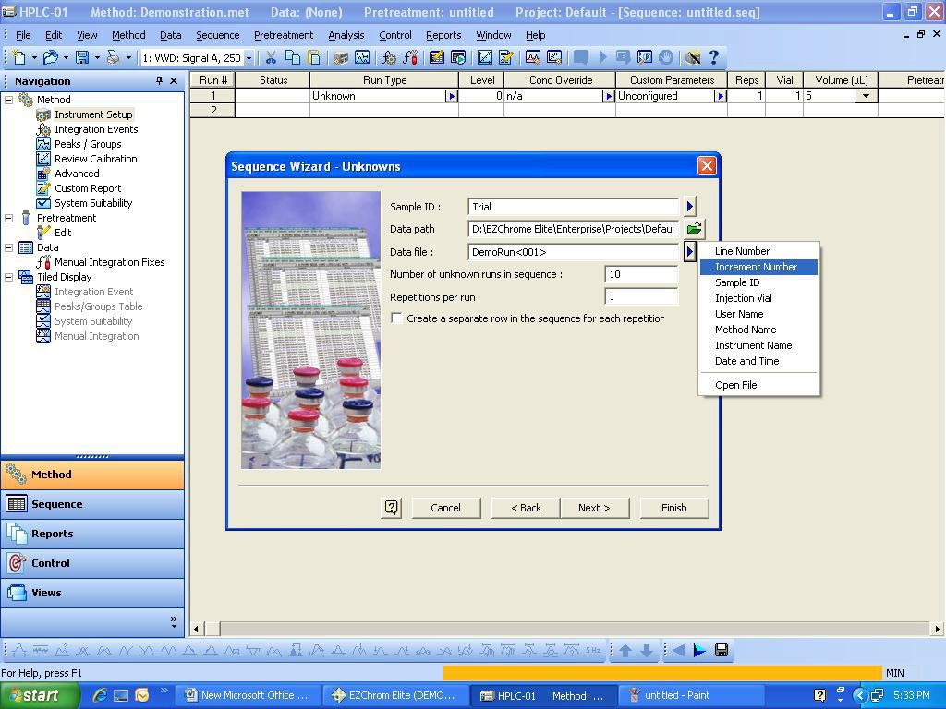

* + 1. The below screen will appear. Browse and select the running Result name by clicking on  the running sequence name will come automatically. After this, just click on Submit and this will run the added lines in the sequence and the data will be saved in the running Result Set.

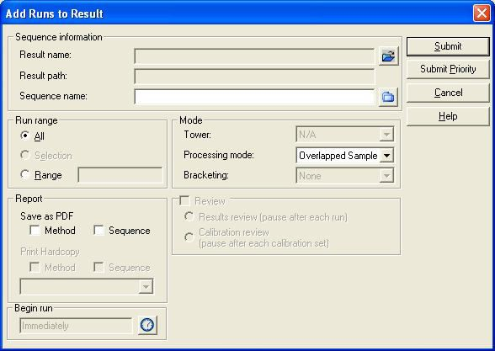

* + 1. After completing the single run the below Results Review Mode screen will appear. In this mode you cannot change or edit the instrument parameter like flow etc. So to access the instrument parameters, click control -> Monitor HPLC.

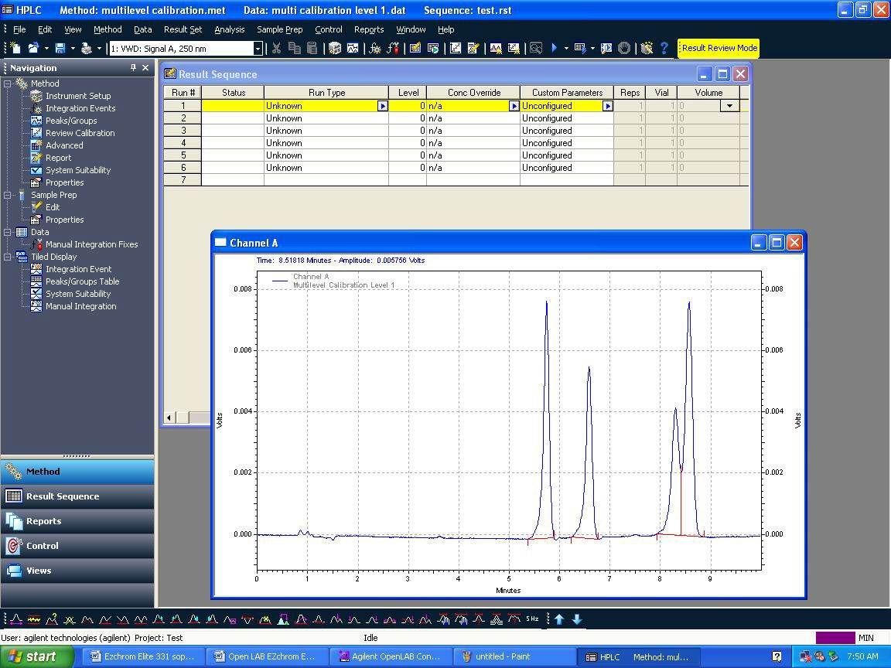

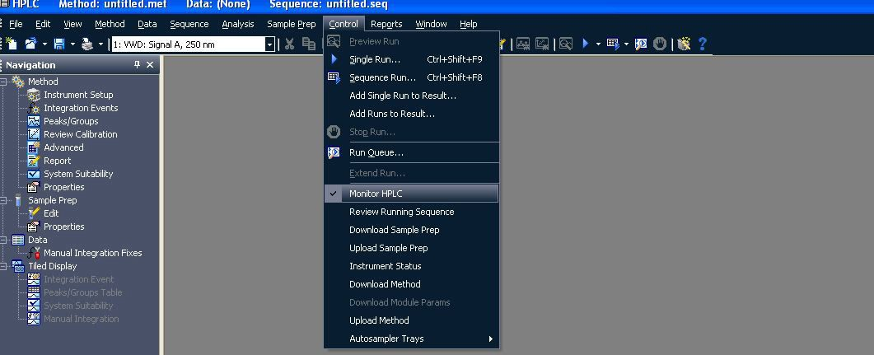

* 1. **How to access acquired data integrate data, assign peak name, process sequence:**
     1. In the Control Panel -> Select Instrument -> select the project -> click on Launch Offline.

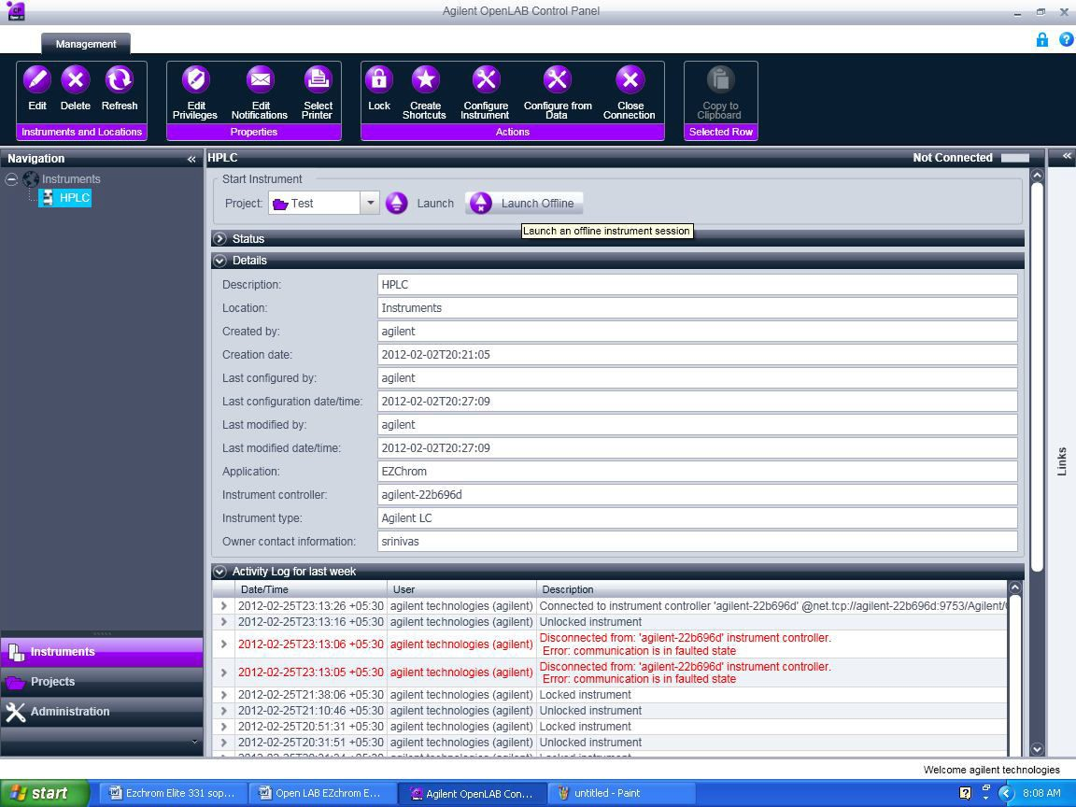

* + 1. The below screen will appear and close the instrument Wizard.

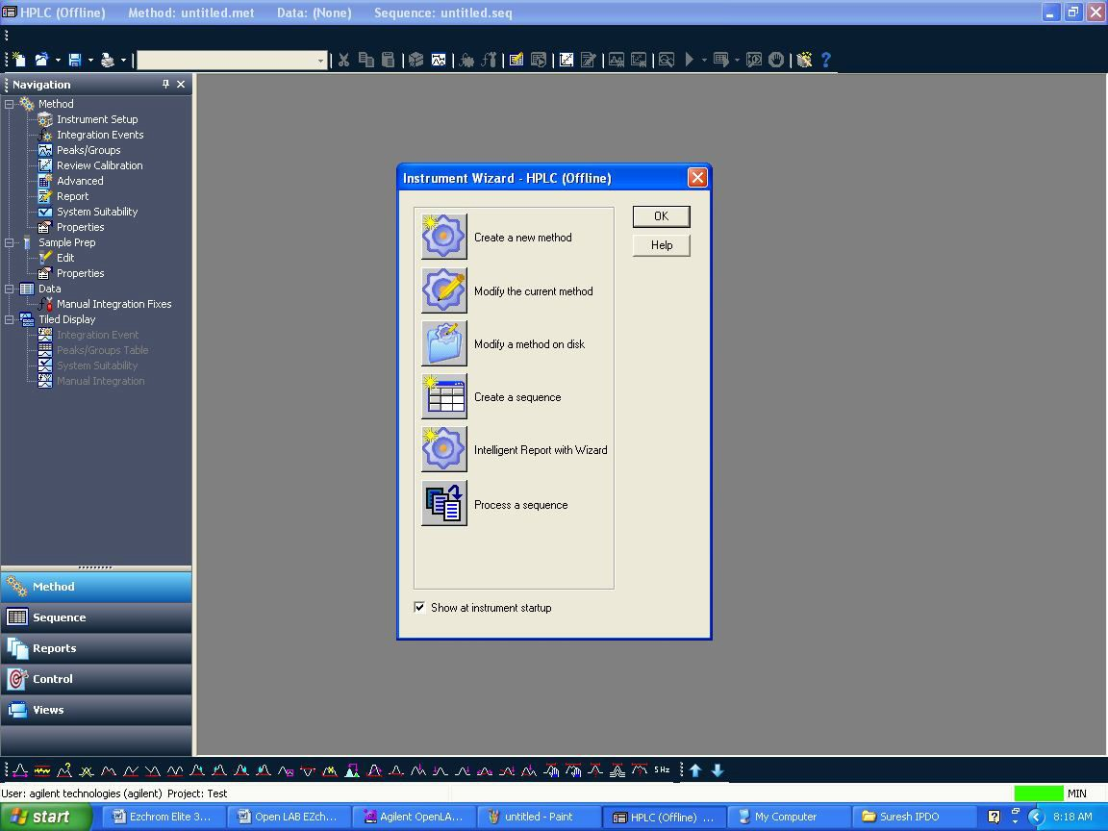

* + 1. Click File -> Open -> Result Set…

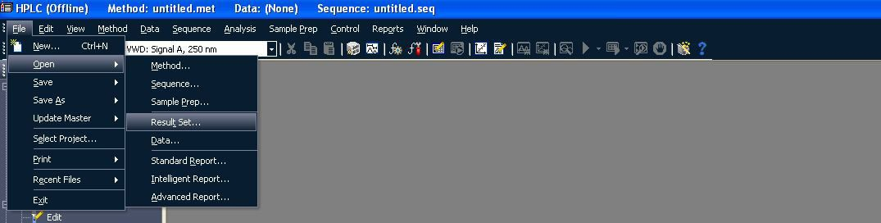

* + 1. The below window will appear and select the required Result Set and click on Open

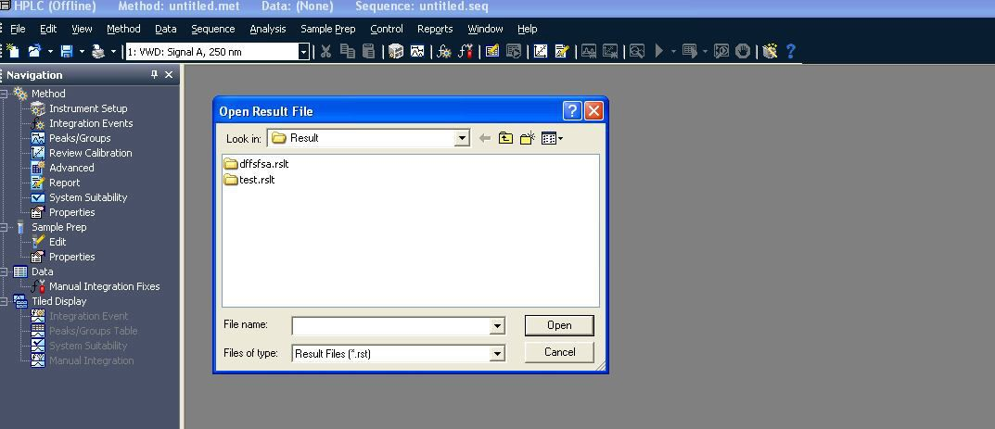

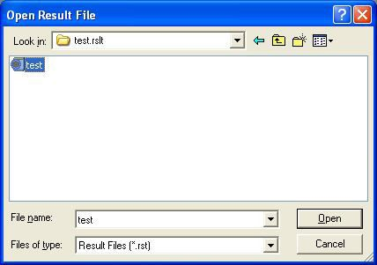

* + 1. The below screen will appear once you click Open. The Result Set will be opened along the Method.

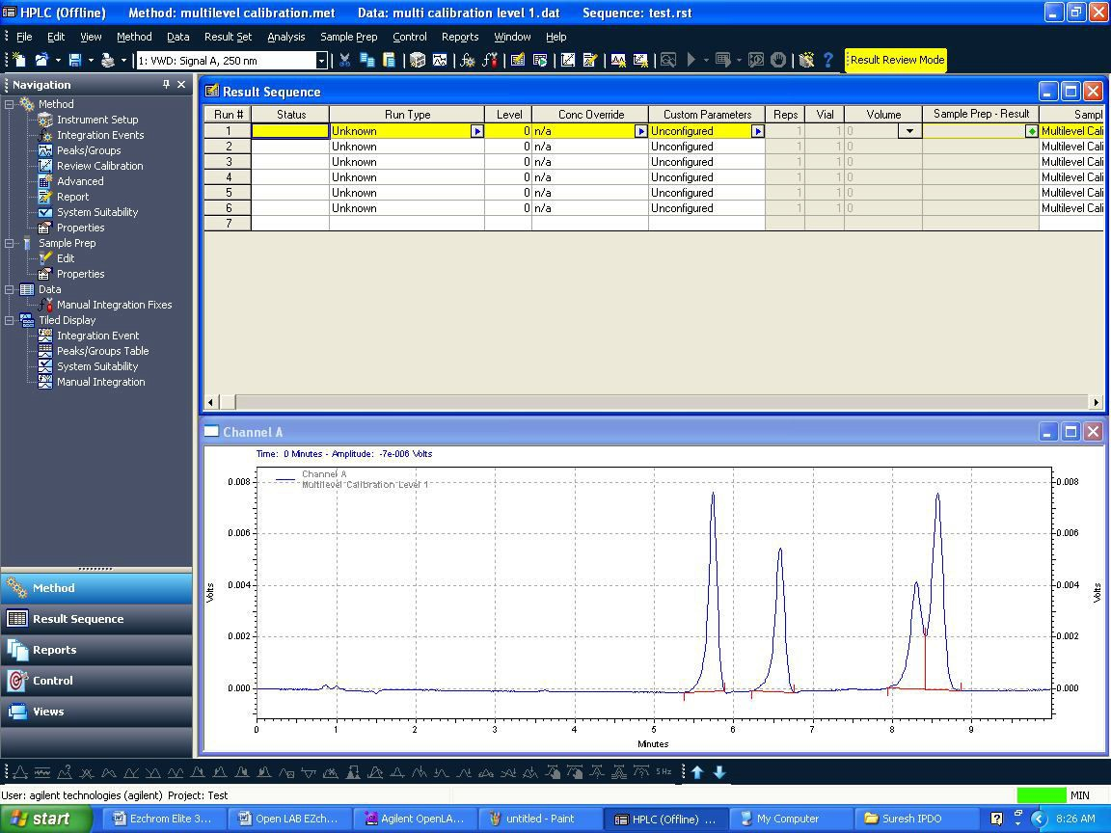

* + 1. To open a data just right click on any line and click on Select Record it will open the data file OR just double click on any line it will open the data file.

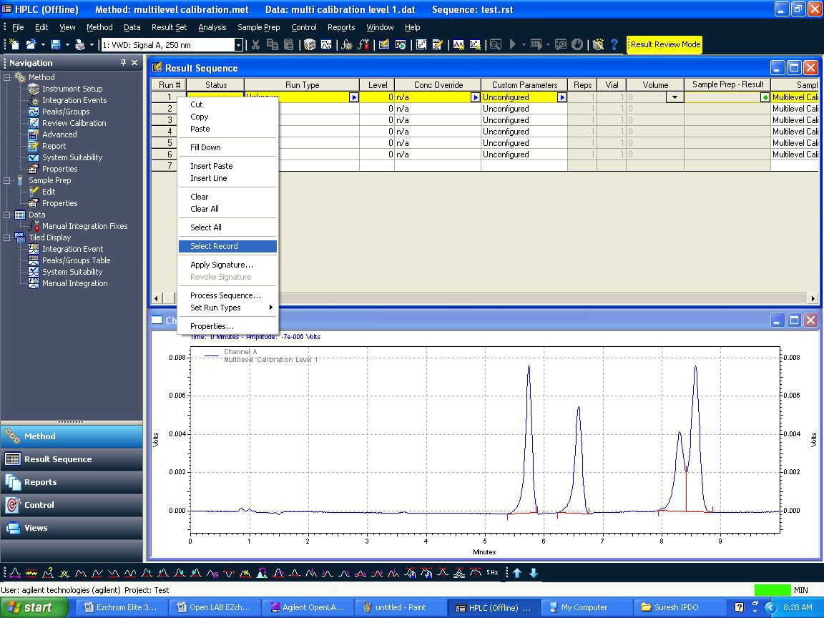

* + 1. To integrate chromatogram, integration events are available.
    2. By right click on chromatogram →Graphical Programming →list will be displayed, from that you can use different integration events like integration off, valley to valley etc.

**OR**

* + 1. You can integrate chromatogram using graphical tools i.e. available at the bottom in the same window.

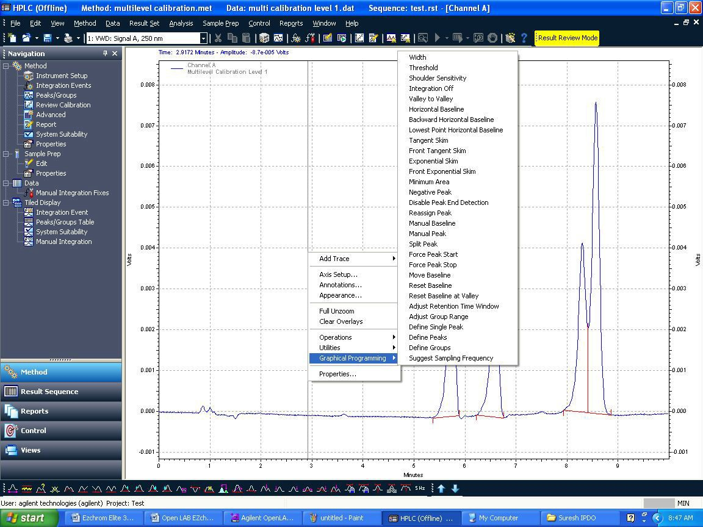

* + 1. If you integrate by using graphical tool, the below screen will appear with integration parameter and in the same window you will be asked to select two options,
    2. Option-1: “Add event to Method (all data)”
    3. Option-2: “Applicable for all the data files.
    4. And if you select Option-2, only the particular the data which is open will be integrated. Add event to the data file only”.
    5. Here if you select Option-1, the events will be added to method.

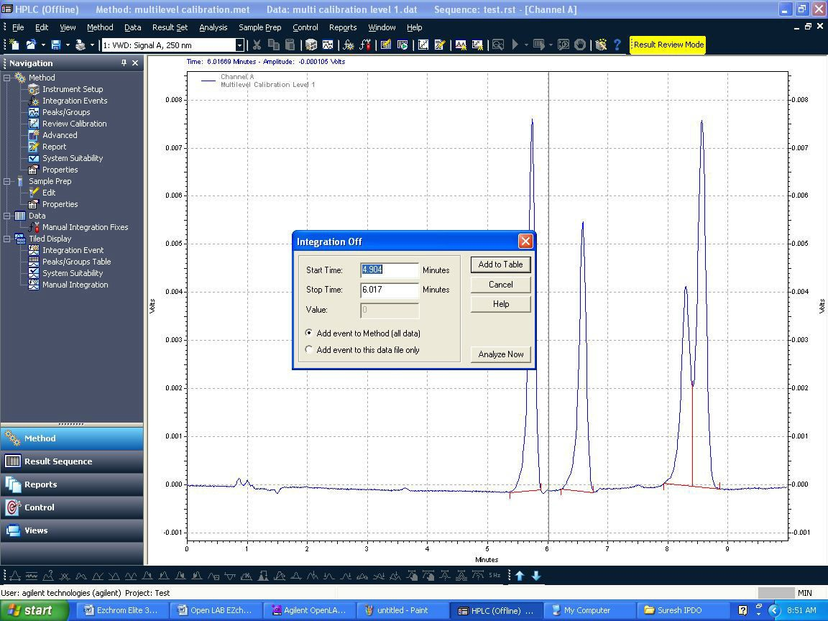

* 1. **Calibration :**
     1. **Calibration Schedule:** Every 4 months.
     2. **SYSTEM PRECISION and DETECTOR SENSITIVITY:**
        1. **Chromatographic Conditions:**

Column : DB-624, 0.53mm x 30m, 3.0µm

Injection Temperature : 280°C

Detector Temperature : 300°C

Pressure : 5.0

Split Ratio : 1:10

Injection Volume : 1.0 µL

Runtime : 15.00 minutes

Oven Temperature : Kept the temperature 180°C for 15 minutes.

* + - 1. **Preparation of Standard Solution:**

Prepare 100 mg/µl solution of each n-Dodecane, n-Tetradecane and n- Hexadecane in n-Heptane.

**Preparation:** Weigh accurately about 50.0 mg of each n-Dodecane, n-Tetradecane and n-Hexadecane in n-Heptane in 50ml Volumetric flask and makeup to volume with n-Heptane. Take 1.0 ml of this solution, make to the volume of 10 ml with n-Heptane.

* + - 1. **Acceptance Criteria:**

1. The RSD of area counts for each n-Dodecane, n-Tetradecane,n-Hexadecane is not more than 15.0
2. The RSD of Retention times for each n-Dodecane, n-Tetradecane, n-Hexadecane is not more than 5.0
   * 1. **FID Sensitivity should be > 10 x 10 -3 c/g**

FID Sensitivity = Average Area of n-hexadecane x 10-6 x 1000

W

* + 1. **Detector Linearity:**
       1. FID-A

Column : DB-624 (0.53 ID, 30 M length, 3.0 µ film thickness

Oven Temp : 100°C (Isothermal)

Injector temp : 180°C

Detector temp : 260°C

Flow rate : 5 ml/ min

Injection volume : 2.0µL

Run Time : 5 min

Spilt Ration : 10:1

* + - 1. **1.0% solution of Benzene and Toluene (Solution–S):**

Pipette out 1.0 ml of Benzene and 1.0 ml of toluene in to a 100 ml volumetric flask make up to the mark with Methanol.

* + - 1. **Sample Solution (Solution-TS):**

Pipette out 2.0 ml of Solution-S in to a100 ml volumetric flask. Make up to the mark with Methanol

* + - 1. **Solution-1(50ppm):**

Pipette out 0.5 ml solution-S, into a100 ml volumetric flask. Make up to the mark with methanol.

* + - 1. **Solution-2(100ppm)**:

Pipette out 1.0 ml solution-S, into a100ml volumetric flask. Make up to the mark with methanol

* + - 1. **Solution-3 (150ppm):**

Pipette out 1.5 ml solution-S, into a100ml volumetric flask. Make up to the mark with methanol

* + - 1. **Solution-4 (200ppm):**

Pipette out 2.0 ml solution-S, into a100ml volumetric flask. Make up to the mark with methanol**.**

* + - 1. **Solution-5(300ppm):**
      2. ipette out 3.0 ml solution-S, into a100ml volumetric flask. Make up to the mark with methanol.
      3. Procedure: Inject 2.0µl of solution-1, 2, 3, 4, and 5 for FID-A Separately. Calculate the peak area ratios between Benzene, Toluene Separately. Calculation coefficient correlation for benzene and Toluene.
      4. **Result**: The response of the detector should be linear for above concentrations. The coefficient of correlation should not be less than 0.99.
    1. **Oven temperature calibration:**

Set the column oven temperature at 40°C, 100°C, 150°C, 200°C and 280°C respectively and measure the temperature attained at each setting by placing the temperature probe inside the column compartment.

**Acceptance criterion:** The temperature attained inside the column compartment should be within ±2°C for 40°C and ±5°C for 40°C, 100°C, 150°C, 200°C and 280°C to the set temperature.

1. **FORMATS / ANNEXURE(S):**
   1. Instrument Usage log Book : QC048-FM088
   2. GC Calibration Record : QC045-FM076
2. **CHANGE HISTORY:**

| **Revision No.** | **Effective Date** | **Details of Revision** | **Ref CCF No.** |
| --- | --- | --- | --- |
| 00 | 29.08.2016 | New SOP introduced | -- |
| 01 | 01.01.2017 | 1. SOP format changed make to in line with SOP-QA-001-04. 2. In calibration procedure    1. In Oven temperature calibration at 280°C was introduced instead of 250°C.    2. Detector Linearity calibration the coefficient of correlation should not be less than 0.99 instead of 0.98. | QC-CRF-025/16 |